**Configure Azure SQL with ASP.Net Web Application**

Azure SQL Database is a general-purpose relational database, provided as a managed service. With it, you can create a highly available and high-performance data storage layer for the applications and solutions in Azure. SQL Database can be the right choice for a variety of modern cloud applications because it enables you to process both relational data and non-relational structures, such as graphs, JSON, spatial, and XML.

**Use Cases:**

* Relational data storage for cloud-based applications and web sites
* Business and consumer web and mobile apps
* Manage databases for multi-tenant apps
* Quickly create dev and test databases to speed up development cycles
* Scale production business services quickly and at a known cost
* Containerize data in the cloud for isolation and security
* Outsource database management in order to focus on value-added services

**Step 1:** Open Microsoft Azure Portal

<http://portal.azure.com/>

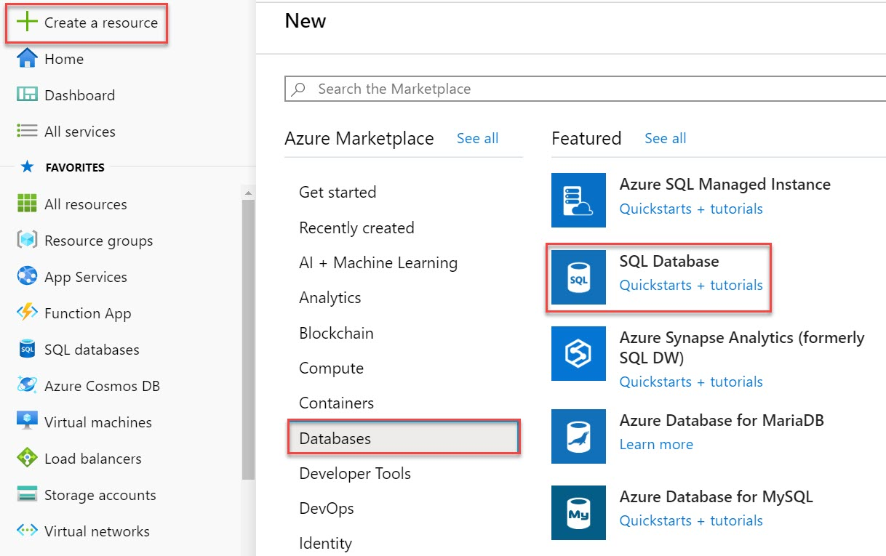

**Step 2:** Create SQL Database

Subscription: **Choose any active Subscription**

Resource Group: **Create New Resource Group Ex. SQLDemoRG**

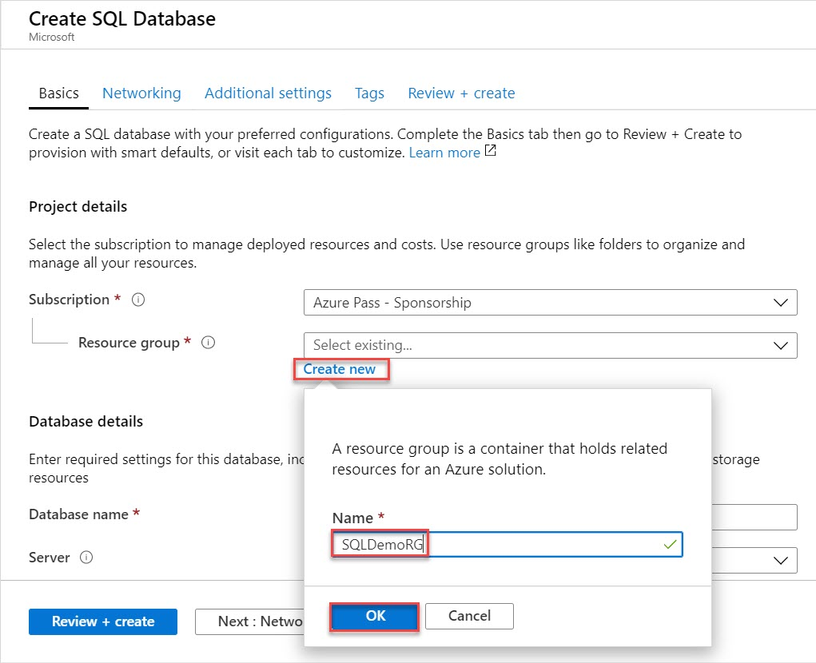

**Step 3:** Database name: **enter sql database name ex. empdb**

Server: **Create New Server**

Server Name: **Enter unique name ex. empsrvr01**

Server admin login: **demouser**

Password: **demo@pass123**

Confirm Password: **demo@pass123**

Location: **Choose nearest location**

Click on **OK** button

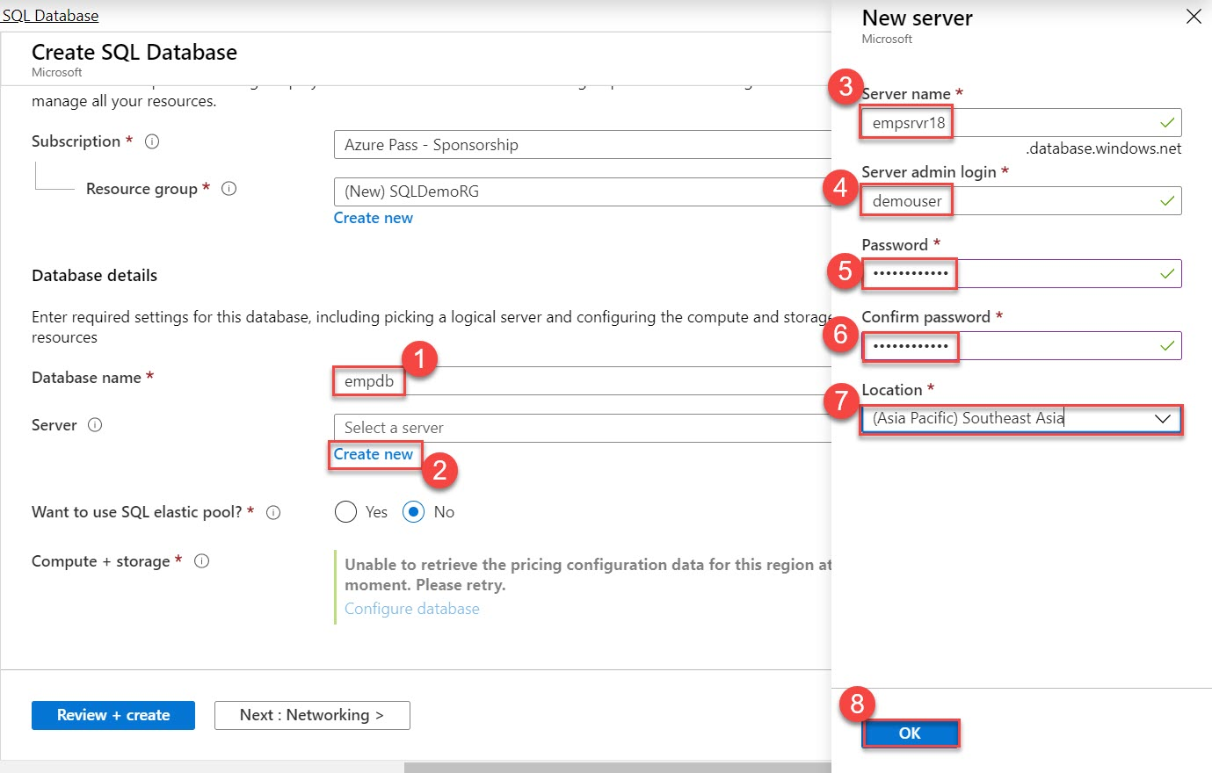

**Step 4:** Want to use SQL elastic poo? : **No**

Compute + Storage: **Click on Configure database**

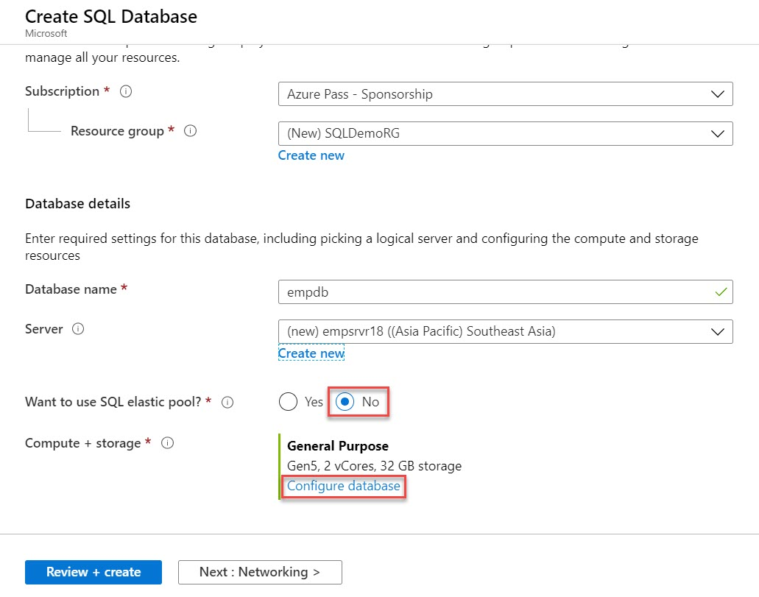

**Step 5:** For this demo we are not using General purpose but basic is fine. Choose **Basic** option

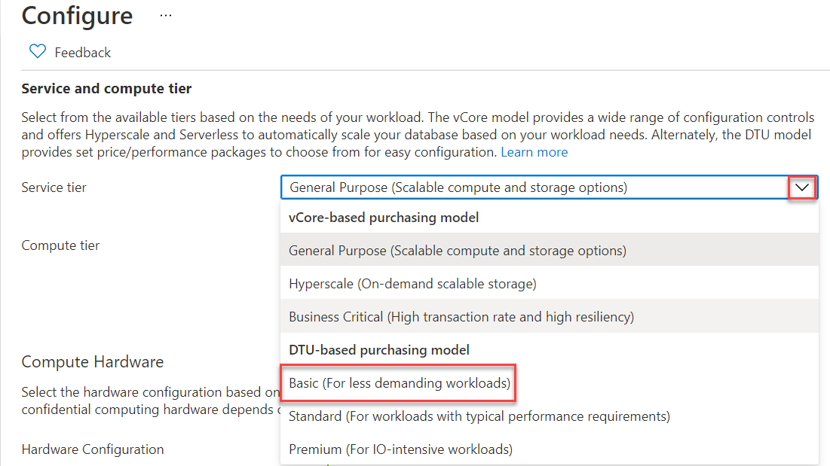

**Step 6:** Click on **Apply** button

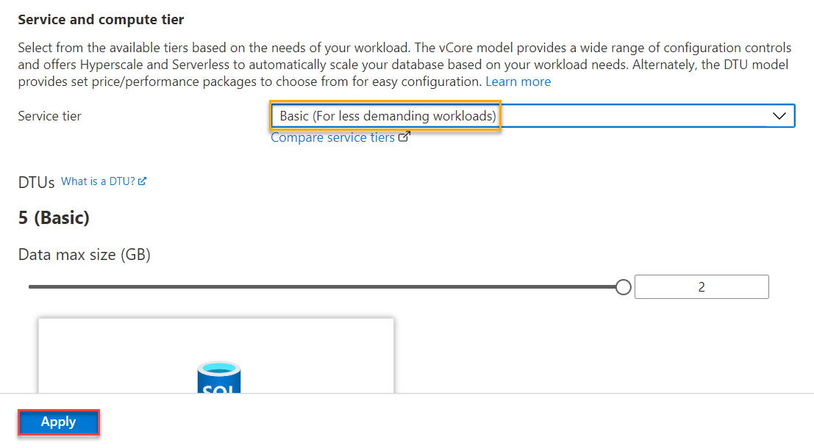

**Step 7:** Backup storage redundancy: **Locally-redundant backup storage**

Click on **Next: Networking >** button

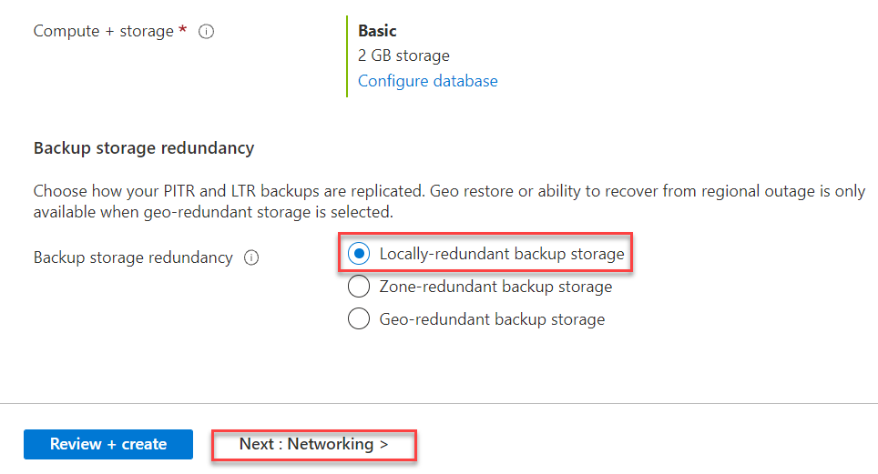

**Step 8:** Connectivity method: **No access**

Click on **Next: Security >** button

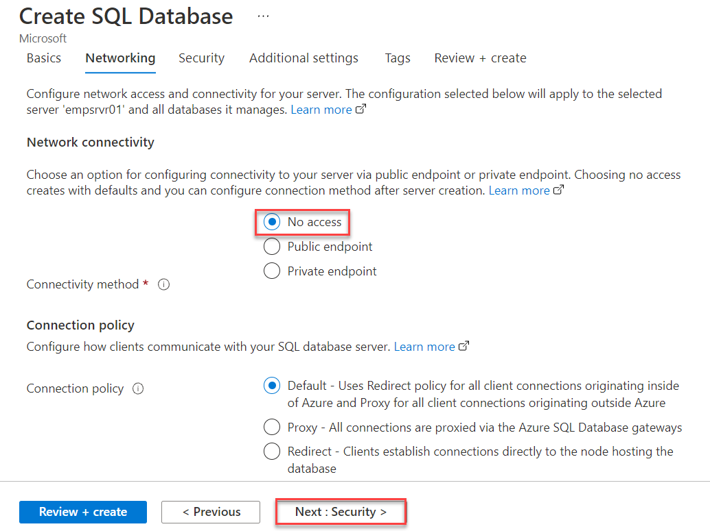

**Step 9:** Click on **Next: Additional settings >** button

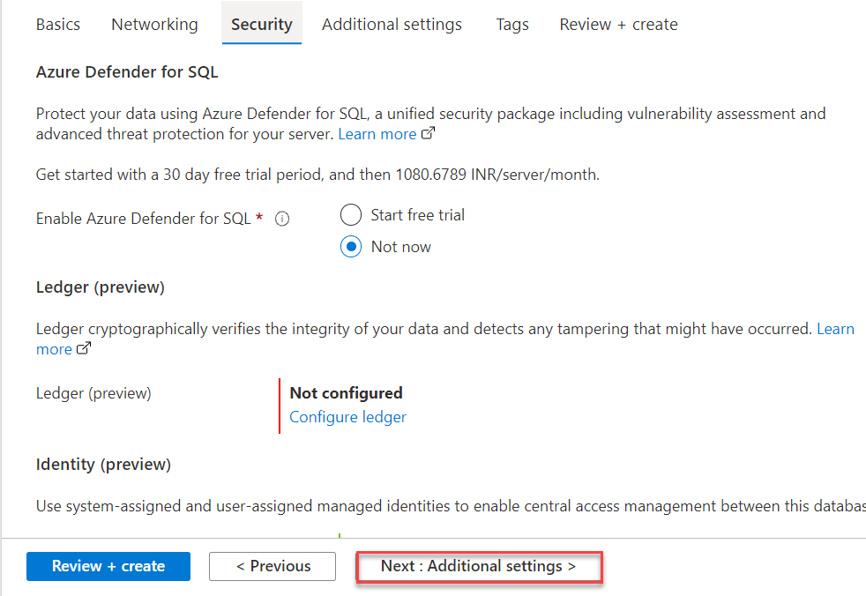

**Step 10:** Click on **Next: Tags >** button

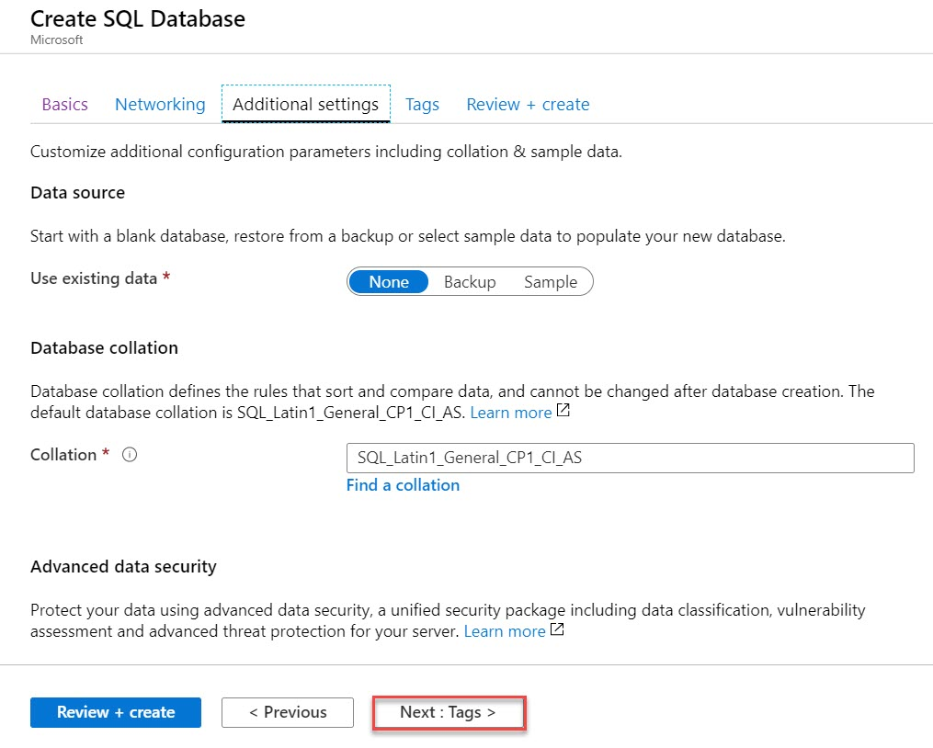

**Step 11:** Click on **Next: Review + create >** button

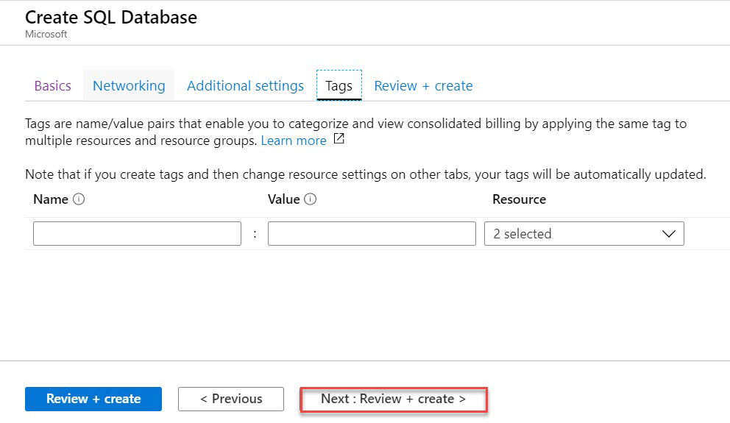

**Step 12:** Click on **Create** to deploy Azure SQL Database.

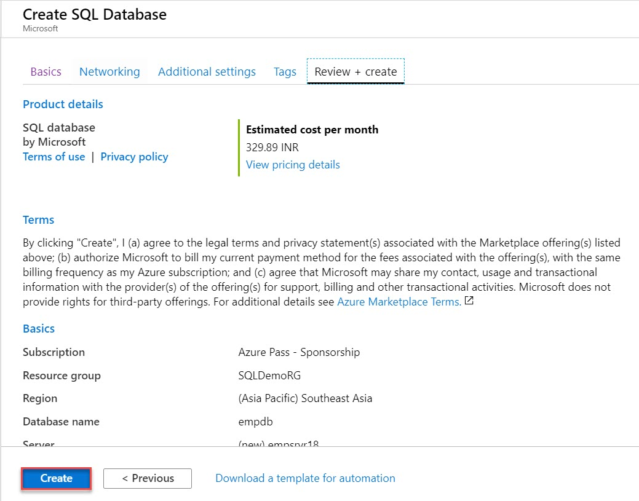

**Step 13:** Click on **Go to resource** button

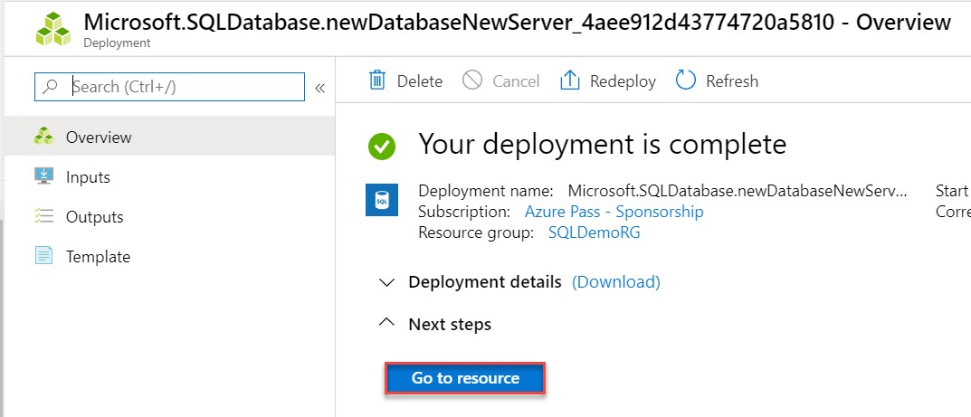

**Step 14:** As in last step we have selected no access option so require to configure IP Address.

So click on **Set Server firewall** option.

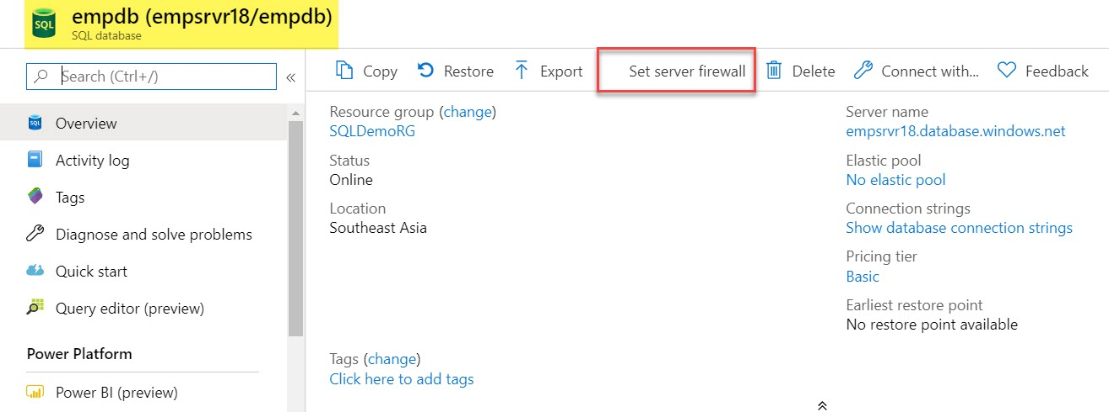

**Step 15:** Click on **+ Add client IP**

Allow Azure services and resources to access this server: **ON**

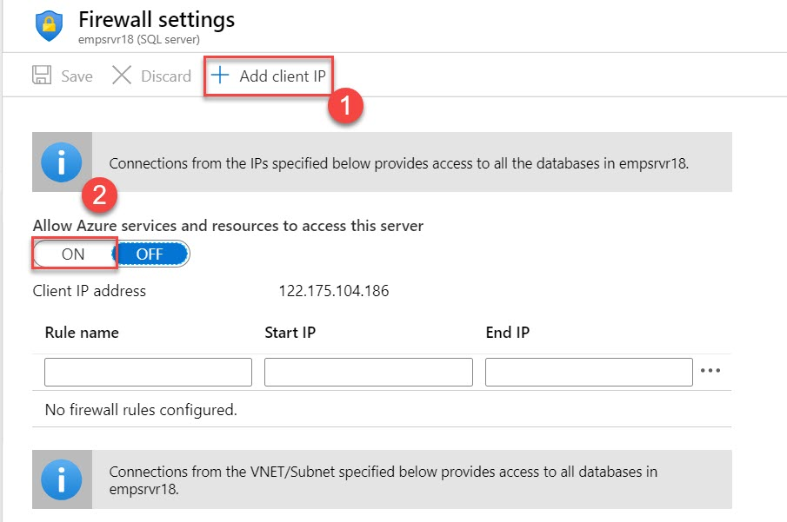

**Step 16:** Click on **Save** option

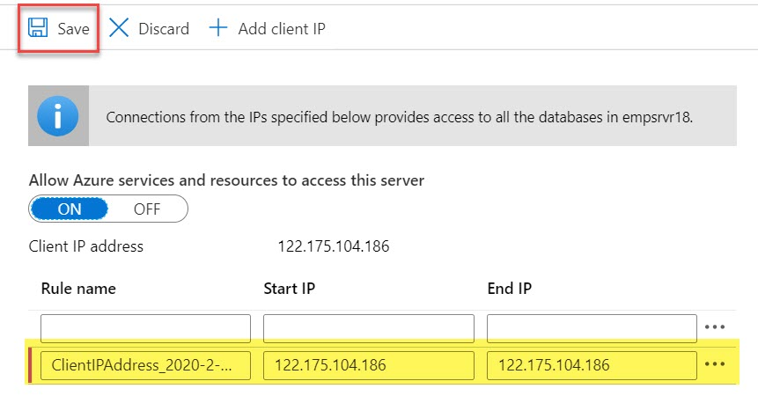

**Step 17:** Click on **OK** button

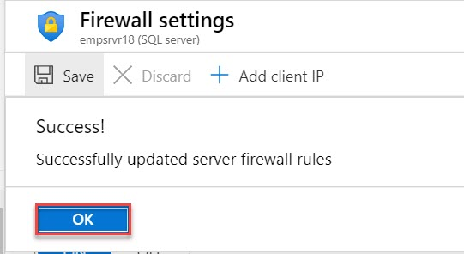

**Step 18:** Now open **Visual Studio 2019**

Open **View** menu -> **SQL Server Object Explorer** option

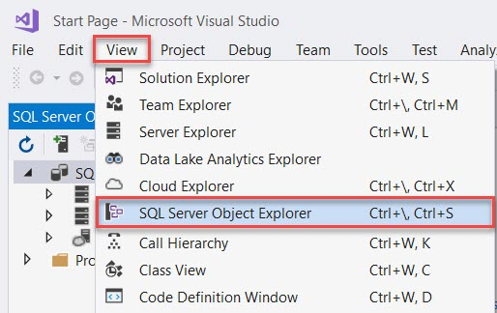

**Step 19:** Click on Add New Connection option

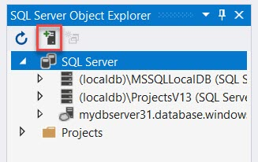

**Step 20:** For connection we require Server Name, Authentication, User Name, Password and Database.

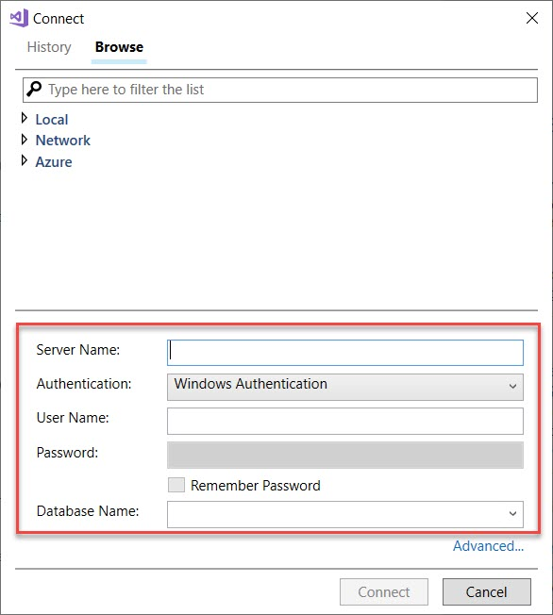

**Step 21:** Navigate to Azure Portal and Copy Server Name

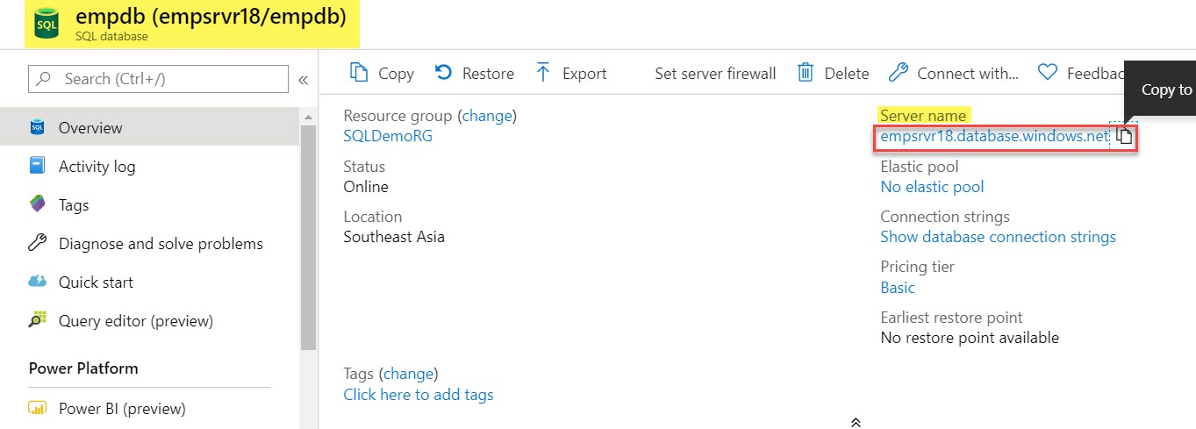

**Step 22:** Paste all the information

Server Name: **Collected from last step**

Authentication: **SQL Server Authentication**

User Name: **demouser**

Password: **demo@pass123**

Database Name: **Choose database from list ex.** **empdb**

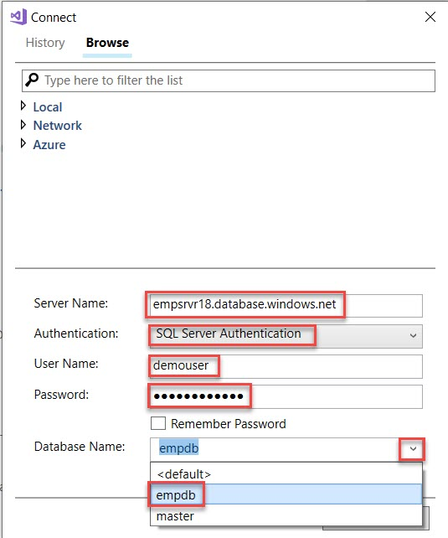

**Step 23:** Click on **Connect** button

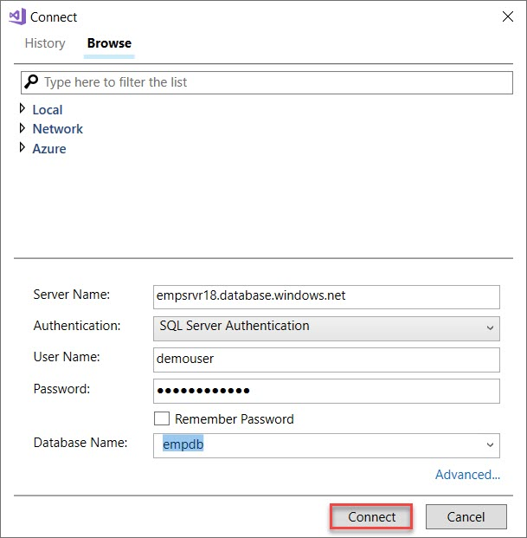

**Step 24:** Now Azure SQL Server connected with Visual Studio SQL Server Object Explorer.

**Expand Server -> Databases -> empdb -> Tables ->** Right click on **Tables** andselect **Add New Table…**

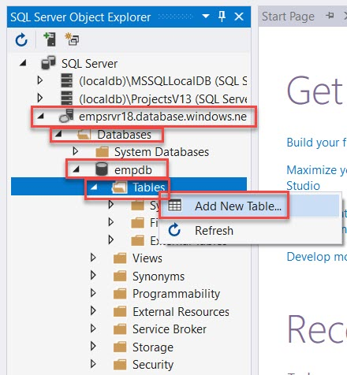

**Step 25:** Remove old Table query and Update with below Table query.

CREATE TABLE [dbo].[empTable]

(

[Id] INT NOT NULL PRIMARY KEY,

empName nvarchar(50),

MobileNo nvarchar(50),

City nvarchar(50)

)

**Step 26:** Click on **Update** option

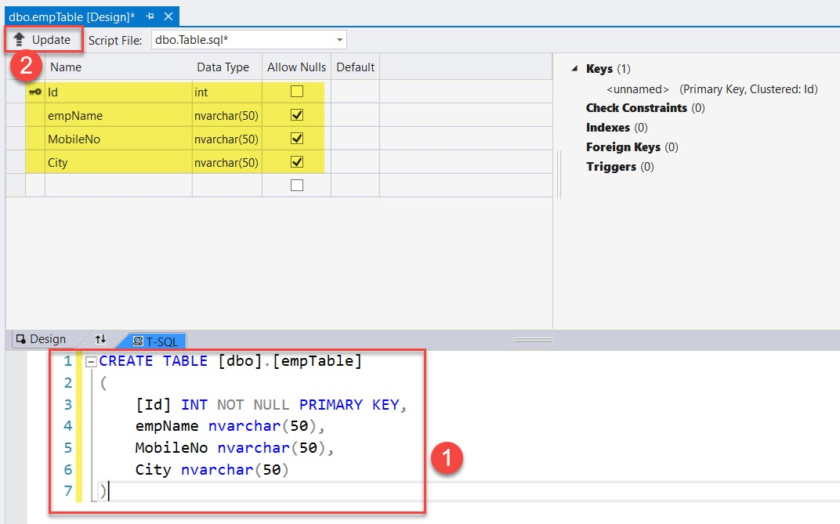

**Step 27:** Click on **Update Database** to Update on Azure SQL Server

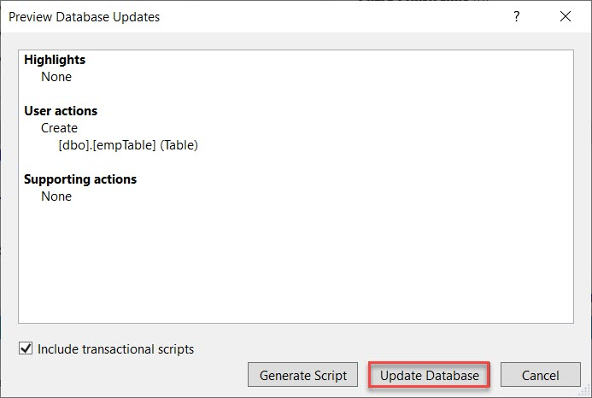

Wait for couple of minutes

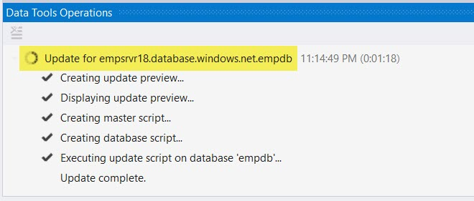

Now you can see status Updated and Table also created: **dbo.empTable**

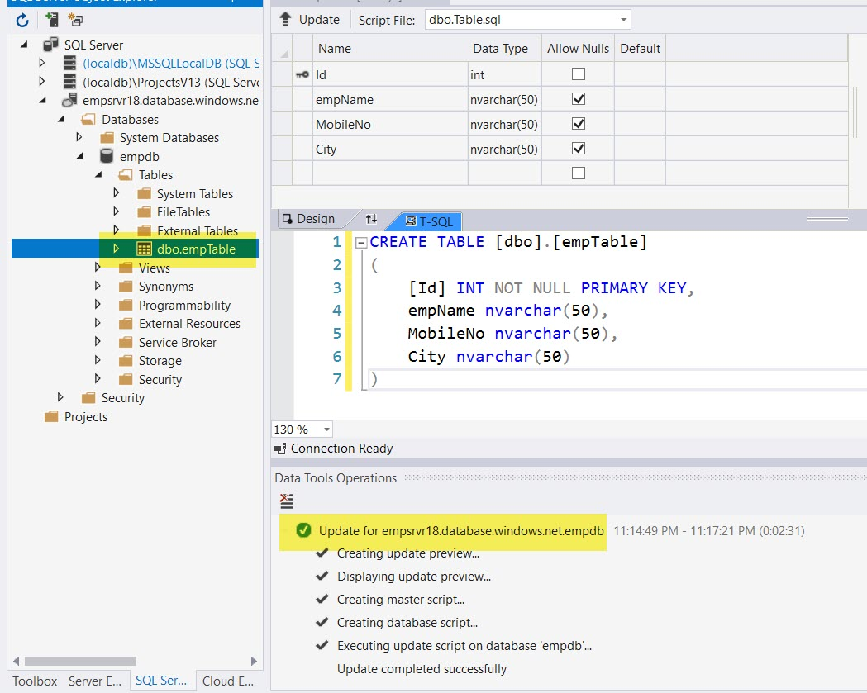

**Step 28:** With Same Visual Studio Create New ASP.NET Web Application

Start **Visual Studio 2019**

Click on **Create a new project** option

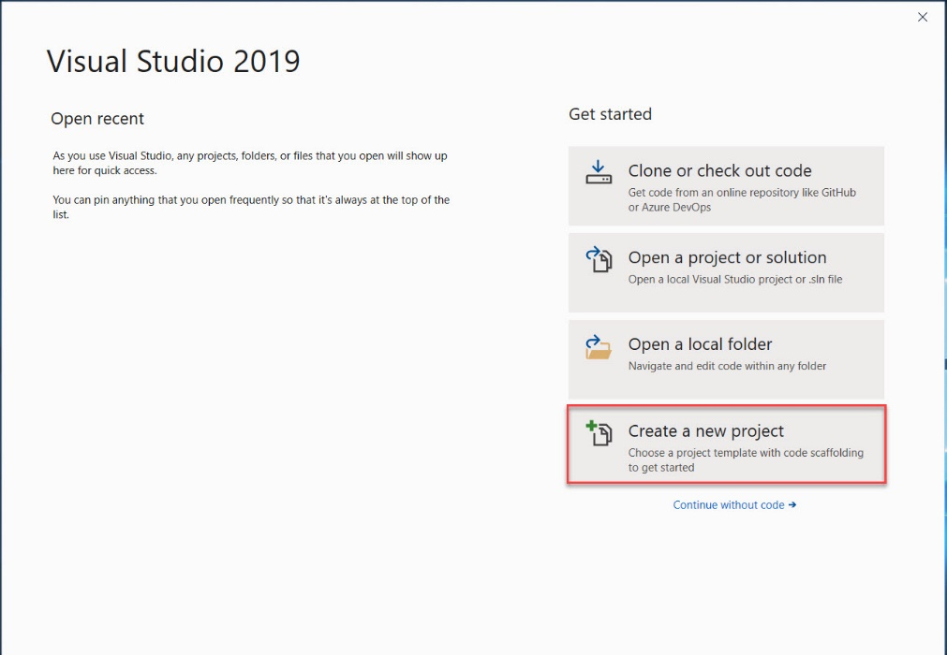

**Step 29:** Create a new project

Change Language: **C#**

Search for “**web application**”

Click on **ASP.NET Web Application (.Net Framework)** project

Click on **Next** button

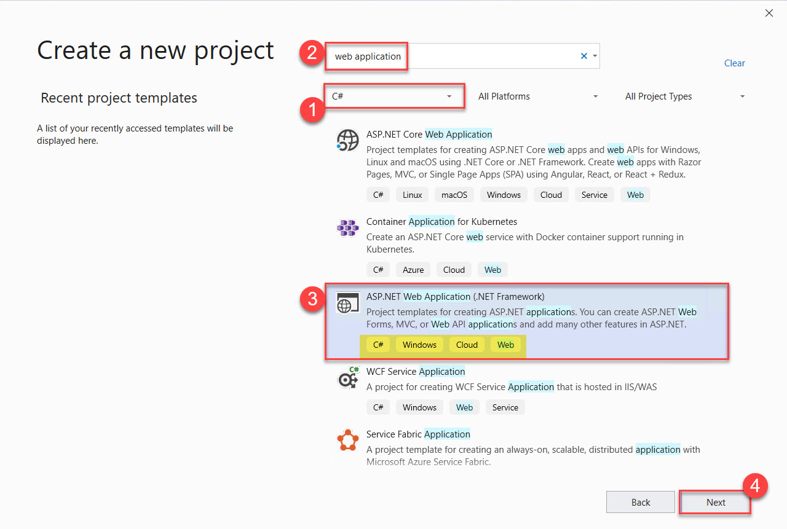

**Step 30:** Configure project

Update Project Name: **AzureSQLDemo**

Click on **Create** button.

**Step 31:** Choose **Empty Project** and click on **Create** button.

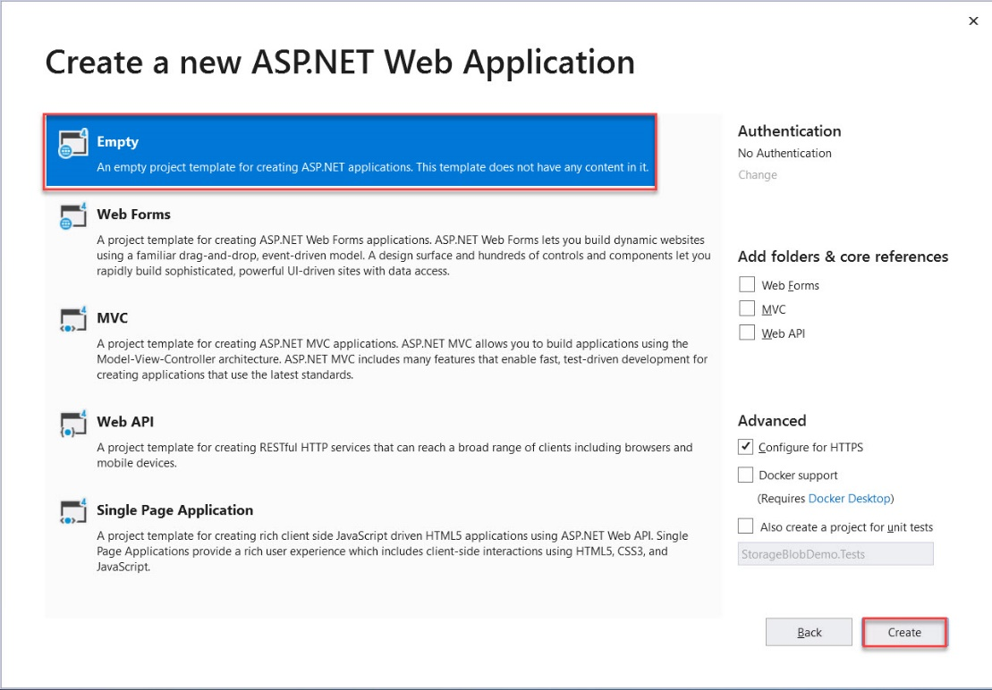

**Step 32:** Right click on **Project Name -> Add -> New Item…** option

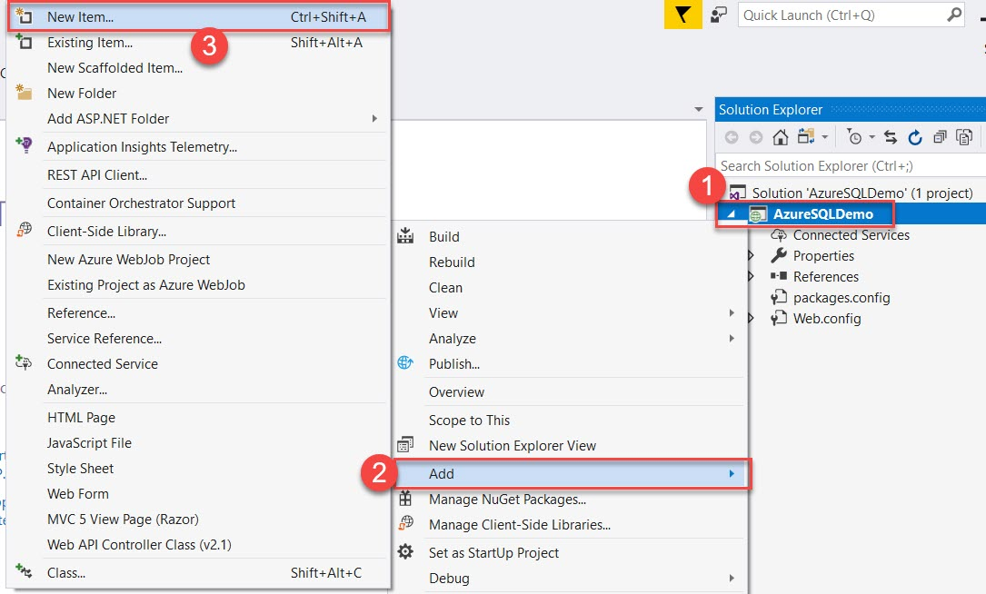

**Step 33:** Choose Data option and ADO.NET Entity Data Model

Name: EmpModel

Click on Add button

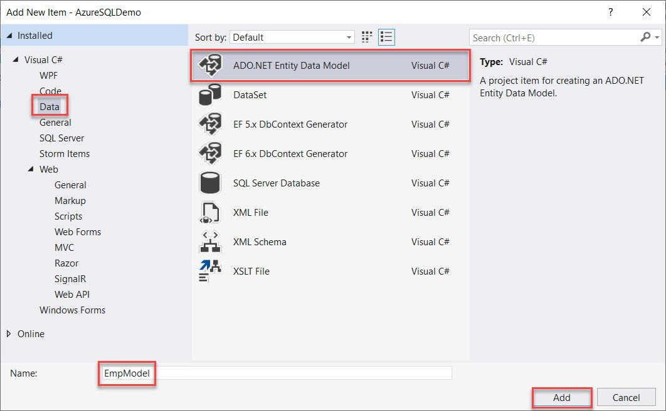

**Step 34:** Model: EF Designer from database and click on Next > button

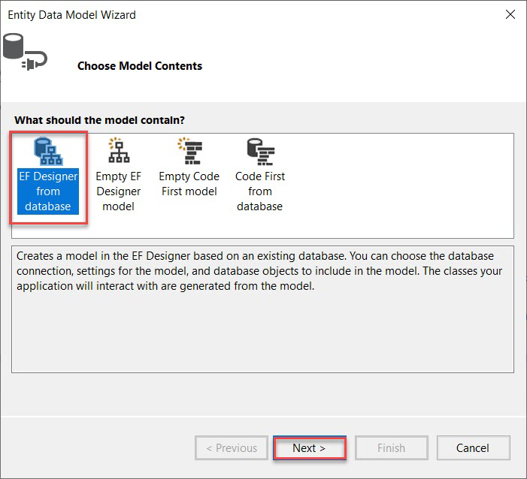

**Step 35:** Click on New Connection….

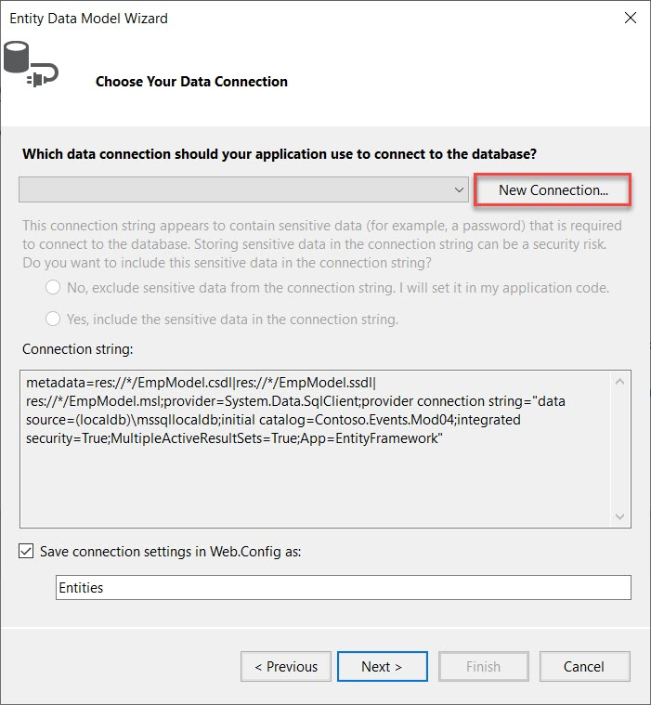

Insert Server Name

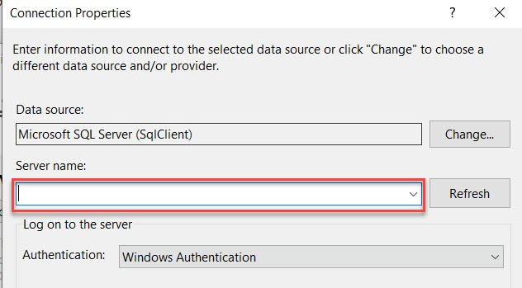

Again, Navigate to Azure Portal and copy Server Name.

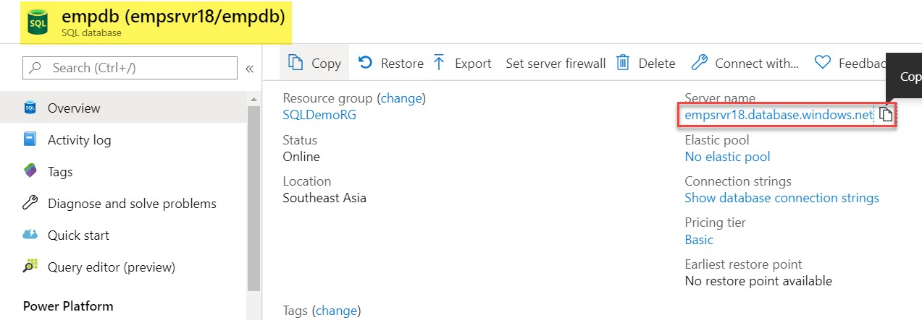

**Step 36:** Enter Connection Details

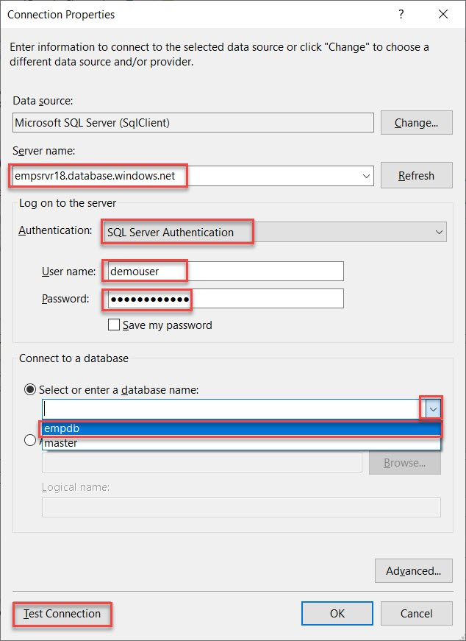

Server Name: Collected from last option

Ex. empserver.database.windows.net

Authentication: SQL Server Authentication

User name: **demouser**

Password: **demo@pass123**

Database: **empdb**

Click on Test Connection option

If test connection succeeded, proceed with next step.

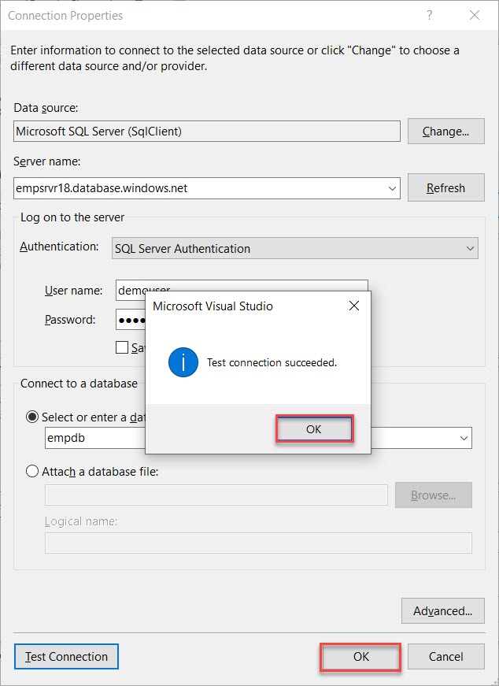

**Step 37:** Choose Yes option

Click on Next button

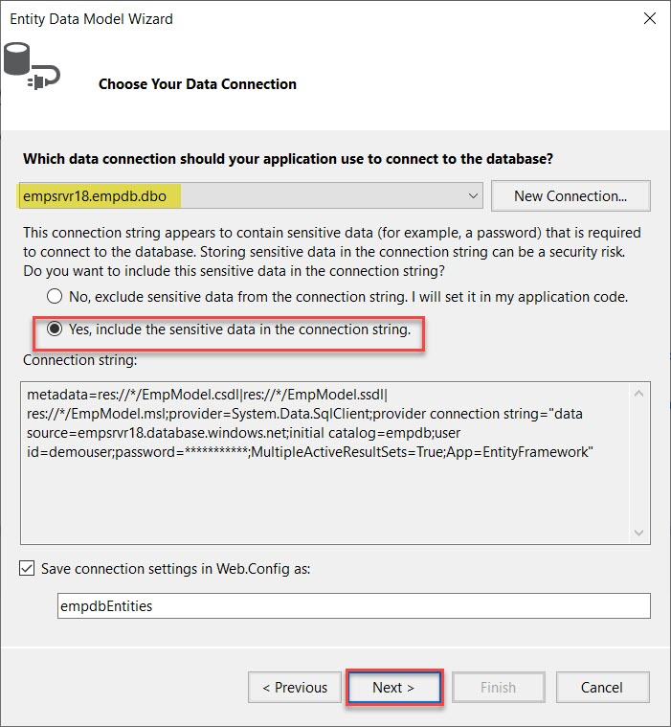

Choose Entity Framework version: Entity Framework 6.x

Click on Next button

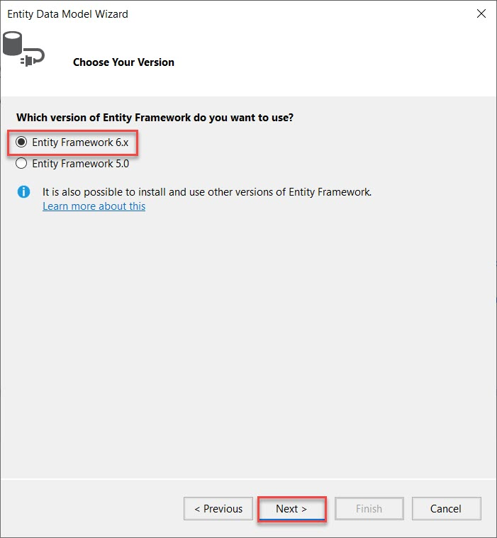

Expand Tables and select empTable option

Click on Finish button

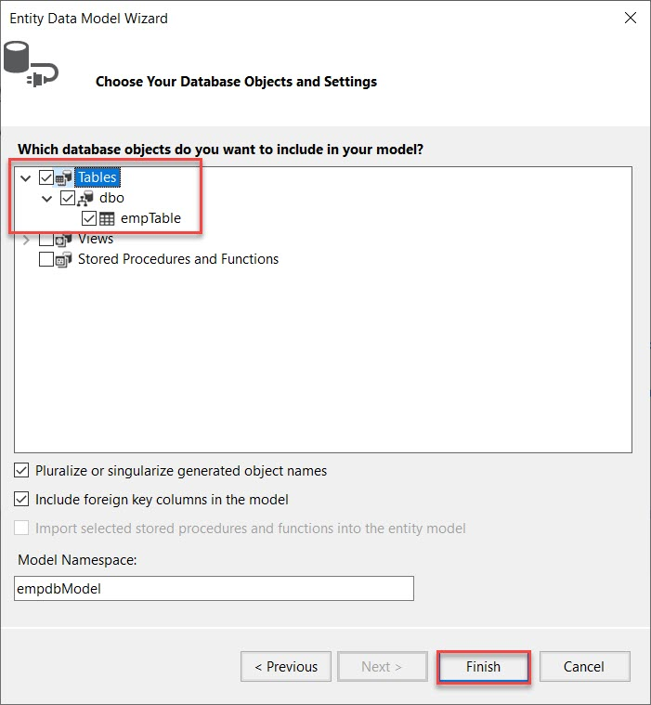

Click on OK button.

Note: Security Warning dialog will open 3-4 times so click on OK button every time.

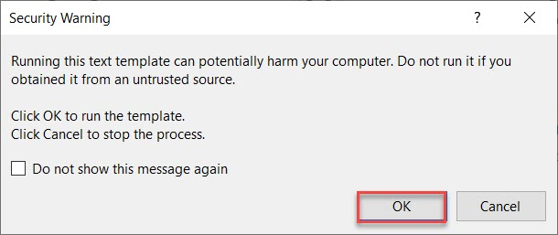

Model generated

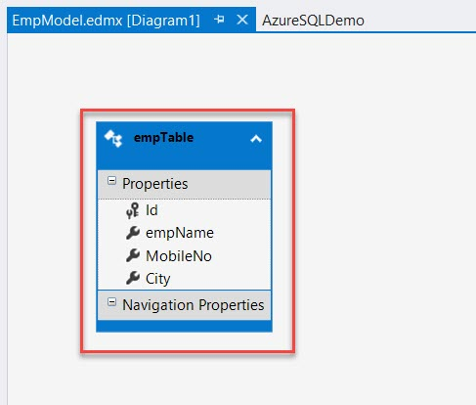

**Step 38:** Add New Web Form

Right click on Project Name -> Add -> Web Form option

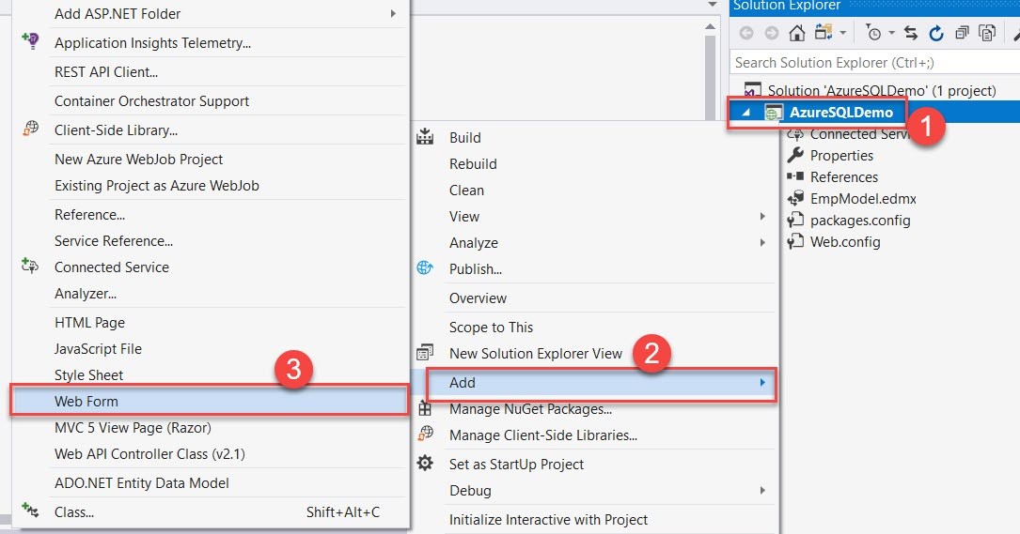

Item Name: index

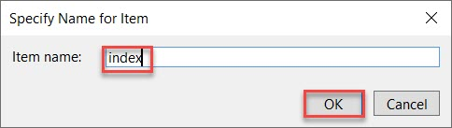

**Step 39:** Update below code:

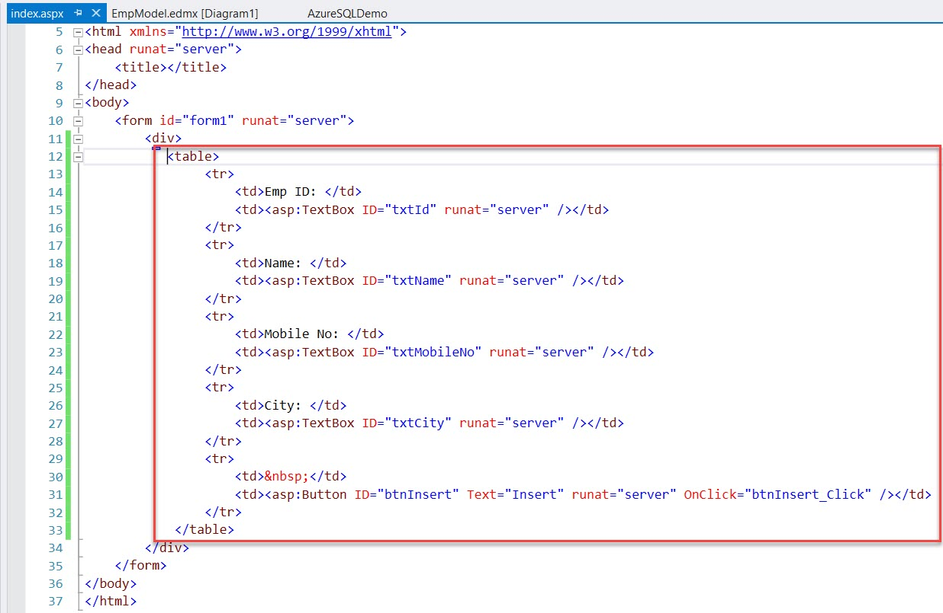

<body>

<form id="form1" runat="server">

<div>

<table>

<tr>

<td>Emp ID: </td>

<td><asp:TextBox ID="txtId" runat="server" /></td>

</tr>

<tr>

<td>Name: </td>

<td><asp:TextBox ID="txtName" runat="server" /></td>

</tr>

<tr>

<td>Mobile No: </td>

<td><asp:TextBox ID="txtMobileNo" runat="server" /></td>

</tr>

<tr>

<td>City: </td>

<td><asp:TextBox ID="txtCity" runat="server" /></td>

</tr>

<tr>

<td>&nbsp;</td>

<td><asp:Button ID="btnInsert" Text="Insert" runat="server" OnClick="btnInsert_Click" /></td>

</tr>

</table>

</div>

</form>

</body>

**Step 40:** Open index.aspx.cs file

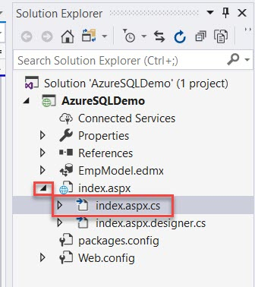

**Step 41:** Add Button click Event as below:

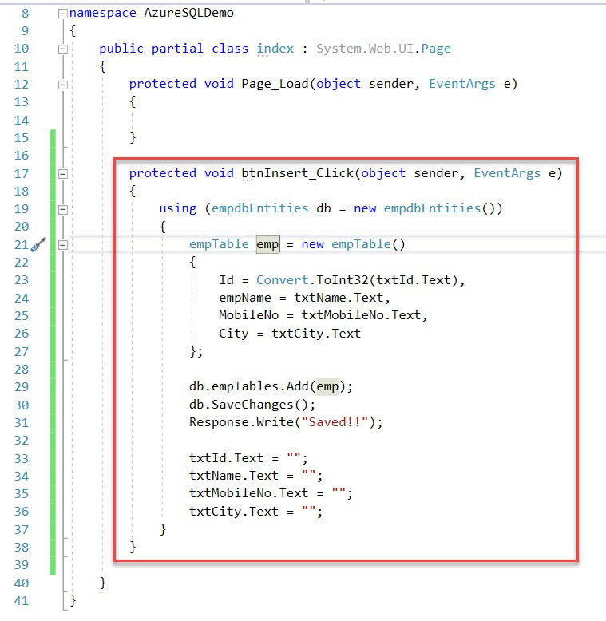

namespace AzureSQLDemo

{

public partial class index : System.Web.UI.Page

{

protected void Page_Load(object sender, EventArgs e)

{

}

protected void btnInsert_Click(object sender, EventArgs e)

{

using (empdbEntities db = new empdbEntities())

{

empTable emp = new empTable()

{

Id = Convert.ToInt32(txtId.Text),

empName = txtName.Text,

MobileNo = txtMobileNo.Text,

City = txtCity.Text

};

db.empTables.Add(emp);

db.SaveChanges();

Response.Write("Saved!!");

txtId.Text = "";

txtName.Text = "";

txtMobileNo.Text = "";

txtCity.Text = "";

}

}

}

}

**Step 42:** Save all and Run the project

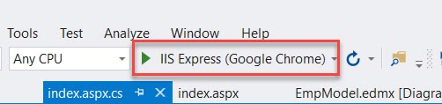

**Step 43:** Enter details and click on Insert button

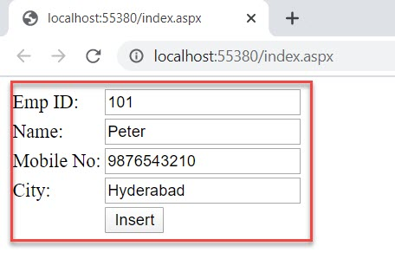

Saved! Successfully.

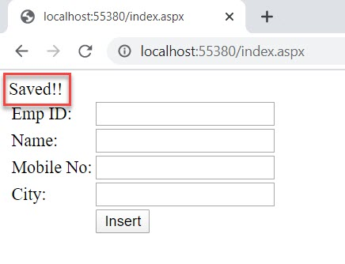

**Step 44:** Navigate to SQL Server Object Explorer

Right click on Table name -> View Data option

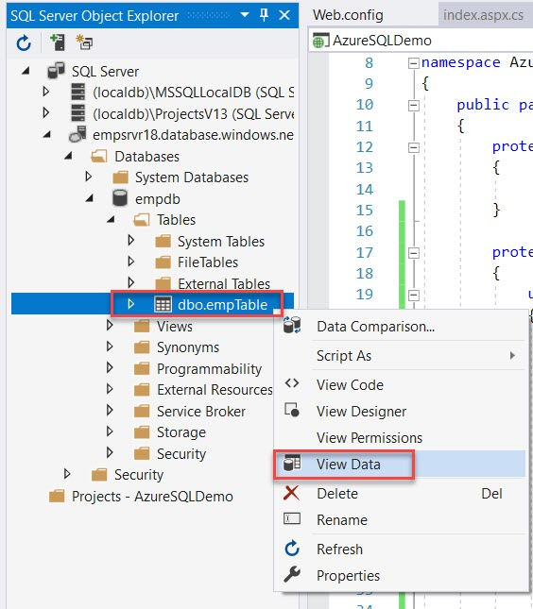

Check record available.

